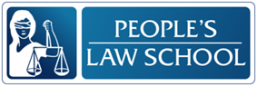

Learning about the Law:
Fundamentals of the Law

CLB 7-8 Instructional Package

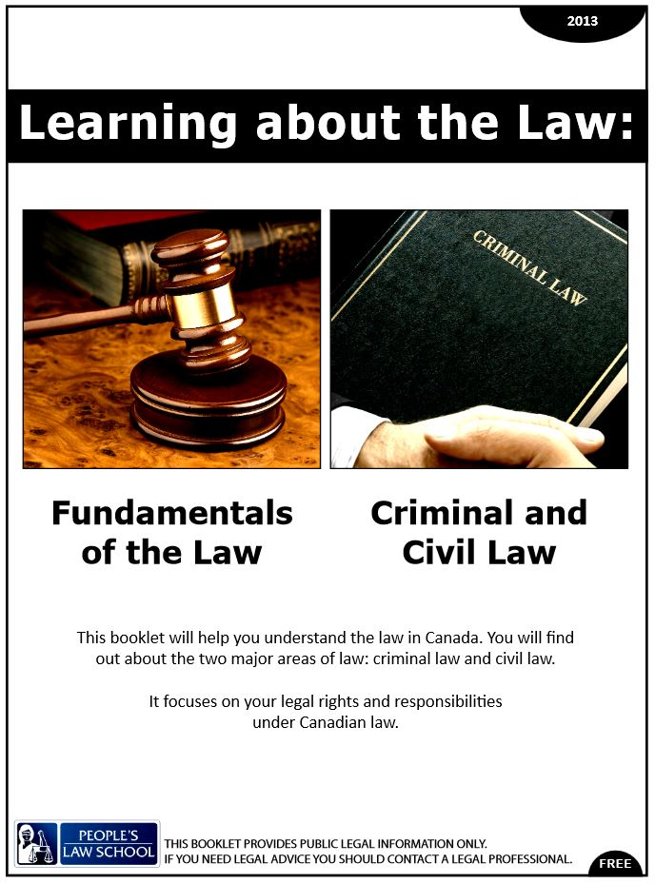

Lesson Plan: Fundamentals of the Law (CLB 7-8)
CLB Outcomes
CLB 8-IV:Comprehending Information | Understand moderately complex extended descriptions, feature articles, reports and narrations.
CLB 7-IV:Sharing Information | Give detailed information; express and qualify opinions and feelings; express reservations, approval, disapproval, possibilities and probabilities one-on-one and in small group discussions or meetings.

Content Outcomes
- Identify constitutional rights and freedoms
- Identify social and civic responsibilities
- Know where to find more information about the fundamentals of Canadian law

Resources
- People’s Law School (PLS) booklet, Learning about the Law: Fundamentals of the Law,
p. 3-7
- PLS worksheets “Learning about the Law: Fundamentals of the Law”
- Computer Lab (optional)

External Resources and Referrals
- For more information on the fundamentals of Canadian Law, visit Immigrant Legal at http://www.immigrantlegal.ca/
- Call Dial-a-Law at 1-800-565-5297
- Visit the local court house (many have orientation programs for newcomers)

Assessment Plan and Tools
- Self-assessment checklist

Lesson Plan: Fundamentals of the Law (CLB 7-8)
Sample Lesson Plans

Time | Sample Tasks | Expected Outcome | Resources
15’ | Warm up  - In pairs or small groups, students discuss terms in a word cloud, identifying what they already know about the topic  - Go over vocabulary, if needed  - Assess level of knowledge of/ interest in the topic | Generate interest  Activate prior knowledge | PLS Worksheet:  Get Ready!
25’ | Predict and read  - Students predict 2 details per content area  - Students confirm their predictions by readingLearning about the Law: Fundamentals of the Law  - Go over any new vocabulary, but encourage students to apply word attack strategies first | Identify constitutional rights, freedoms and social responsibilities  Understand a moderately complex text | PLS Worksheet:  Predict!  Fundamentals of the Law, p. 3-7.
45’ | Vocabulary  - Students practice changing words to different forms  - Students complete a short fill in the blanks with the correct word forms  - Students look for the words in the text | Build vocabulary by analyzing word forms | PLS Worksheet:  Build your Vocabulary!  Fundamentals of the Law, p. 3-7.
15’ | Pronunciation  - Model breaking words into syllables, marking stressed syllables and reducing other syllables to schwa  - Students mark the stress in different forms of the same words  - drill pronunciation  - have students tap or clap on the stressed syllable | Notice how word stress moves when the word form changes  Pronounce multi-syllabic words with correct word stress. | PLS Worksheet:  Say it!
20’ | Analyze social responsibilities  - Think: Students consider the list of responsibilities and questions and make notes  - Pair: Students share their thoughts and opinions with a partner  - Share: Pairs of students share the key points of their discussion with the whole class | Identify social responsibilities and how to fulfill them  Compare social responsibilities across cultures | PLS Worksheet:  Think about it!
30’ | Small group discussion  - In small groups, students discuss the 3 cases; sharing information and giving opinions  - One student takes notes of the main points made in the discussion  - Groups share the key points from the discussion  EXTENSION  - Groups research and present on one of the cases  - Write a “letter to the editor” expressing your opinion of the case | Give detailed information; express and qualify opinions and feelings; express reservations, approval, disapproval, possibilities and probabilities in small group discussions | PLS Worksheet:  Talk about it!
20’ | Research  - Coach and support students finding the required information  - Refer students to the last few pages of the PLS Learning about the Law booklet for suggested websites | Find more information about the fundamentals of Canadian law | PLS Worksheet:  Find out More!
10’ | Self-Assessment  - Allow students to fill out self-assessment form independently | Self-assessment | PLS Worksheet: What did you learn?

Lesson Plan: Fundamentals of the Law (CLB 7-8)
Get Ready!
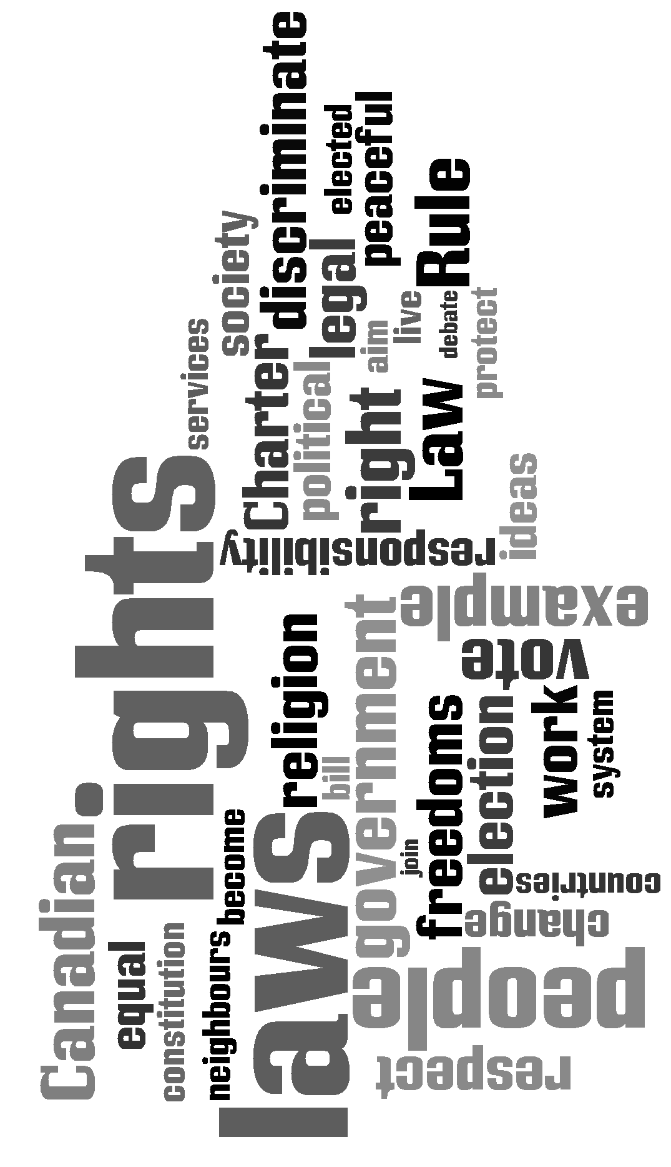
What do you know about the fundamentals of the law in Canada? Look at the words below. What ideas come to mind? What are some rights and responsibilities that all Canadians have?

Lesson Plan: Fundamentals of the Law (CLB 7-8)
Predict!
You are going to read a booklet called Learning about the Law: Fundamentals of the Law, p. 3-7. Look at the learning outcomes for this booklet (below). For each outcome, list 2 or more things that you expect you will read.
In this section, you will learn about:
 | 2 things I expect to read
Canada’s laws | - based on British law  - protects people’s rights
Canada’s constitution
your rights and responsibilities
the Rule of Law
who makes the laws
levels of government
Canada’s Queen

Read and Check!

Read the People’s Law School (PLS) booklet, Learning about the Law: Fundamentals of the Law, p. 3-7 and confirm your predictions.

Lesson Plan: Fundamentals of the Law (CLB 7-8)
Build your Vocabulary!
Being able to transform words into different parts of speech will help you turn your passive vocabulary (words you know when you see or hear them) into active vocabulary (words you use when you speak or write). Fill in the chart below and then put the correct version of the word into the sentences. If you are unsure of the meaning, look for it in context in the text, talk to your classmates and teacher, or use a monolingual dictionary.

Noun | Verb | Adjective
society
 | govern
 |  | legal
guilt
 | protect
 |  | discriminating
regulation
 | politicize
 |  | symbolic
persuasion

- Because you can make use of _____________ services in Canada, you must pay taxes.
- We need laws to help _____________ society.
- _____________, police officers and rich people must also obey the laws in Canada.
- The Queen is the _____________ head of Canada.
- Canadians have the right to be thought of as innocent until they are proven ________.
Can you find forms of the above words in sentences in the PLS booklet?
Lesson Plan: Fundamentals of the Law (CLB 7-8)
Say it!
In English words, one syllable gets more stress. This makes the vowel sound longer, louder, higher and clearer. The other vowels are made weaker and they sound like the schwa sound /ǝ/. Some syllables even disappear. Sometimes the word stress shifts from one syllable to the other in different forms of the same word. Complete the chart below and then practice saying the words with the correct stress.

Spell the word |  | Say the word
politics |  | palǝtǝks
political |  | pǝ litǝkǝl
regulate
regulation
symbol
symbolic
society
social

Say it!
Practice saying the words in sentences. Find sentences in the text or write your own.
Lesson Plan: Fundamentals of the Law (CLB 7-8)
Think about it!
In Canada, rights are associated with responsibilities. Look at this list of responsibilities and consider the questions below. Work alone and make notes on your thoughts. Then, share your thoughts with a partner. Finally, share your thoughts with the whole class.

- Go through this list item by item and think of reasons why it is important to fulfill each responsibility. For example, “It is important to help others in the community because there are many vulnerable people who need help, it creates good social connections, and it makes people feel good.”

- Can you list specific example of how you can fulfill each of these responsibilities? For example, “I am taking responsibility for myself and my family by learning English.”
Respecting other people’s rights
Paying taxes
Obeying the law
Taking responsibility for oneself
and one’s family
Serving on a jury
Voting in elections
Helping others in the community
Protecting and enjoying our heritage and environment

- This list is a set of cultural ideals. This means that we value these things. It doesn’t mean that we all fulfill them all the time. What are some values or responsibilities that people in your first culture share? How are these reflected in law? For example, “In my culture, we value being respectful of our parents. This means that we can’t get married without our parents’ consent.”

- Do immigrants and other newcomers to Canada have the same social responsibilities as people born here? Why or why not?

- Write one question to ask your partner about this topic.

Lesson Plan: Fundamentals of the Law (CLB 7-8)
Talk about it!
Rights and freedoms are often tested when protecting one person’s or group’s rights is weighed against another’s or against the common good. The examples below are real Canadian news stories. In small groups, discuss the following:
- the rights, freedoms and responsibilities at issue
- the costs and benefits of protecting these rights and freedoms
- your opinion
Case 1

1990: Sikh Mounties Permitted to Wear Turbans
Canadian Mounties (RCMP officers) are required to wear a hat as part of their uniform. Observant Sikhs are required to wear a turban as part of their religious sacrament. In 1990, the prohibition against RCMP officers wearing a turban was struck down. Now it is not uncommon to see police officers wearing a turban. For more about this, go to http://www.cbc.ca/archives/categories/society/crime-justice/mounties-on-duty-a-history-of-the-rcmp/sikh-mounties-permitted-to-wear-turbans.html.
Case 2

Canada’s Polygamy Laws Upheld by BC’s Supreme Court
Residents of Bountiful, BC follow the Fundamentalist Church of Jesus Christ of Latter-Day Saints, or FLDS, which practices polygamy as a tenet of their religion. In 2011, Chief Justice Bauman ruled to uphold Canada’s anti-polygamy laws despite the fact that they interfere with the FLDS’ community’s freedom of religion. Bauman justified his decision because of the harm done to women and children in polygamous marriages. For more information, go to http://www.cbc.ca/news/canada/british-columbia/canada-s-polygamy-laws-upheld-by-b-c-supreme-court-1.856480.
Case 3

When is it hate speech?: 7 significant Canadian cases
There is an inherent tension between the right to speak freely and the need to guard against speech that belittles specific groups. Canadians generally believe there must be reasonable limits to what can be said publicly, and the courts have grappled with this on many occasions. For example, in 1984, teacher James Keegstra was charged with hate speech for teaching anti-Semitism to his students. His conviction was later overturned because it was deemed that the anti-hate speech law interfered with his right to freedom of expression. Read more at http://www.cbc.ca/news/canada/when-is-it-hate-speech-7-significant-canadian-cases-1.1036731.
Lesson Plan: Fundamentals of the Law (CLB 7-8)
Find out More!
Use a computer at home or at school to research the questions below.
- What is the Magna Carta and what relation does it have to the Canadian constitution?

- What can you do if you feel that you have been discriminated against (at work, in housing, in education)? Where can you get more information and assistance to protect your rights?

- Name the 3 levels of government, the title of the leader and the name and contact information for current leaders.

Lesson Plan: Fundamentals of the Law (CLB 7-8)
What did you learn?
Fill this out on your own.
 | Yes, I can do this on my own. | I need to review this. | I can’t do this yet.
I can evaluate ideas in a lengthy text, draw conclusions on it and compare it to my opinions.
I can express and qualify my opinions, including expressing approval and disapproval.
I can identify some of the rights and freedoms protected by the Canadian constitution.
I can list some social and civic responsibilities that all who live in Canada share.
I can find more information about Canadian law.

What else did you learn today? What other questions do you have about Canadian law?

Lesson Plan: Protecting Yourself and Your Money (CLB 4)
Build your Vocabulary!
ANSWER KEY
Noun | Verb | Adjective
society | socialize | social  societal
government | govern | governmental  governing  governed
law  lawyer  legality | legalize | legal
guilt | guilt (informal) | guilty
protection | protect | protective  protected
discrimination | discriminate | discriminating
regulation | regulate | regulatory  regulated  regulating
politician | politicize | political
symbol | symbolize | symbolic
persuasion | persuade | persuasive

- Because you can make use of social services in Canada, you must pay taxes.
- We need laws to help regulate society.
- Politicians, police officers and rich people must also obey the laws in Canada.
- The Queen is the symbolic head of Canada.
- Canadians have the right to be thought of as innocent until they are proven guilty.
Lesson Plan: Fundamentals of the Law (CLB 7-8)
Say it!
ANSWER KEY

Spell the word |  | Say the word
politics |  | polǝtǝks
political |  | pǝ litǝkǝl
regulate |  | regyǝ late
regulation |  | re gyǝlation
symbol |  | symbǝl
symbolic |  | sym…bo…lǝc
society |  | sǝ…ci…ǝ…ty
social |  | so…shǝl

