Family Law
Lesson: Family Violence

CLB 7-8 Instructional Package
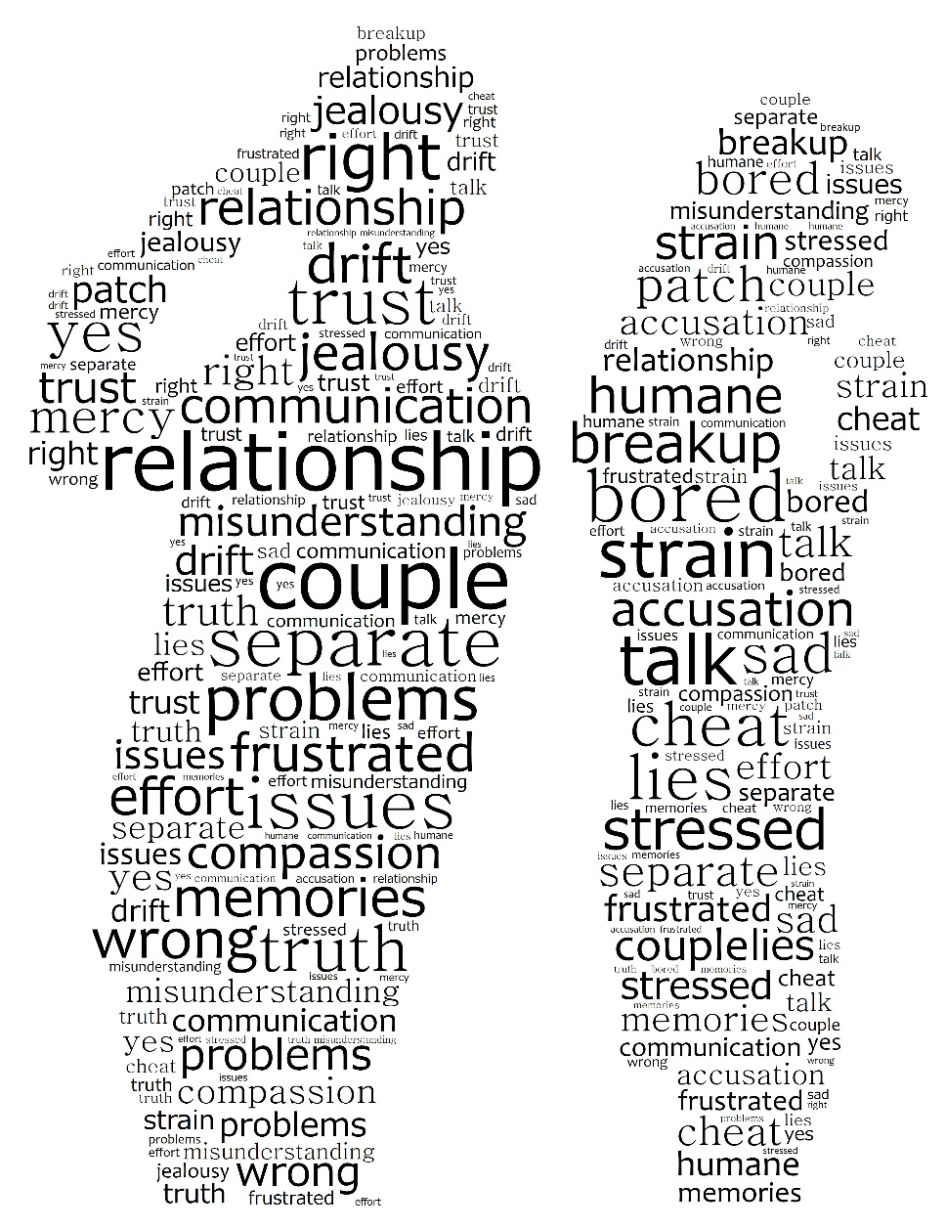

Lesson Plan: Family Violence (CLB 7-8)
CLB Outcomes
CLB 8-II: Comprehending Instructions | Understand extended, moderately complex, multistep instructions and instructional texts for established (set) procedures related to specialized tasks.
CLB8-II: Reproducing Information | Reduce a text of up to about 2 pages to an outline or summary.
Content Outcomes
- Identify what to do in situations of family violence
- Identify the legal protections available to victims of family violence
- Describe the procedures of a criminal court case
- Be able to get more information or find services for family violence

Resources
      - People’s Law School (PLS) booklet, Family Violence & Abuse, section on Legal Protection Against Family Violence
- PLS worksheets “Family Law: Family Violence”
- Computer Lab (optional)

External Resources and Referrals
- For more information on services for victims of family violence, visit Victim Services at http://www.pssg.gov.bc.ca/victimservices/index.htm.
Assessment Plan and Tools
- Self-assessment checklist

To the Instructor:
Family violence is a difficult topic to address in a classroom; Keep the following in mind:
- Alert your coordinator to your intention to cover this topic.
- Review your school policy about referrals.
- Tell the students ahead of time that you will be covering this topic.
- Try to keep the discussion factual, not personal.
- If a student discloses that they are or have been the victim of violence, talk to your coordinator and make a referral.
- Remember, you are not a counsellor.
Lesson Plan: Family Violence (CLB 7-8)
Sample Lesson Plan
Time | Sample Tasks | Expected Outcome | Resources
15’ | Warm up  - Avoid the use of visual images for this topic  - Set discussion ground rules  - Review the language of avoidance and deflection | Set ground rules  Review the language of avoidance and deflection | PLS Worksheet:  Get Ready!
20’ | Predict and read  - Students predict one thing they expect to read and write one question for each of the section of the booklet  - Students scan the PLS Booklet, Family Law: Family Violence, to check their predictions and answer their questions | Develop the reading strategies of prediction and questioning  Scan for details | PLS Worksheet:  Predict!  Family Law: Family Violence
15’ | Vocabulary  - Students analyze the differences between similar words  - Students write and share sentences that illustrate the difference between the similar words  - Teach pronunciation as needed | Apply vocabulary building strategies | PLS Worksheet:  Build your Vocabulary!
40’ | Read and summarize  - Students read the PLS booklet and summarize the key information in a series of graphic organizers  - Students demonstrate an understanding of the procedures for a criminal court case | Take notes and summarize information  Understand procedures | PLS Worksheet:  Read and Summarize!
40’ | Grammar: Conditionals  - Students read and discuss the structure, order of clauses and use of modal verbs in conditional sentences  - In small groups, students match a condition with a result  - They select a modal to complete the sentence, justifying their choice based on certainty  - They can read and check their sentences | Understand court procedures  Demonstrate understanding of key concepts from the reading | PLS Worksheet:  It’s Conditional!
30’ | Research  - Students work independently or in pairs to find the information  - Go over answers | Identify where to get more information about family violence | PLS Worksheet:  Find out More!  Computer lab
10’ | Self-Assessment  - Allow students to fill out self-assessment form independently | Self-assessment | PLS Worksheet:  What did you learn?

Lesson Plan: Family Violence (CLB 7-8)
Get Ready!
You are going to read about family violence. The reading and discussion will focus on keeping safe, Canadian legal protections and court processes, and getting help for yourself and others. However, this topic can be very difficult to talk about and requires great sensitivity.

Before you start, work with your classmates and teacher to set some ground rules. Ground rules are guidelines of expected behaviours for classroom discussions. Here are some examples to get you started. Can you add to the list?

Sample Ground Rules
- Have a clear purpose for the discussion.
- Listen attentively.
- Focus on the technical aspects of the topic (i.e. the laws, the legal processes, etc.)
- Avoid sharing personal details.
- ____________________________________________________________________
- ____________________________________________________________________
- ____________________________________________________________________
Even with ground rules in place, this topic and the opinions of your peers may make you feel anxious. It is okay to take a break or change the course of the conversation.
Review the language of avoidance.
I’d rather not talk about that.
Can we change the subject?
That makes me uncomfortable.
Excuse me. I think I need a break.

Lesson Plan: Family Violence (CLB 7-8)
Predict!
You are going to read a booklet called Family Law: Family Violence. Look at the sections of this booklet (below). For each section, list one thing that you expect you will read and one question you have.
In this section, you will learn about
 | Something I expect to read | A question I have
Overview of family violence and abuse | a definition of abuse | Is yelling and calling someone stupid considered abuse?
Keeping your family safe
Legal Protections
Criminal court process
Who can help

Lesson Plan: Family Violence (CLB 7-8)
Read and Check!
Read the People’s Law School (PLS) booklet, Family Law: Family Violence, and confirm your predictions, and see if your questions were answered.

Build your Vocabulary!
Talk about the words below. What are the similarities and differences? Use examples and definitions to support your points.

- humiliated vs. embarrassed
- blame vs. accuse
- stalk vs. follow
- slap vs. punch
- kidnap vs. abduct
- assault vs. hit
- peace bond vs. protection order
- Crown counsel vs. lawyer
- plead vs. sentence
- bail vs. probation

  - Is the difference in meaning? in degree? in impact? in collocation?
  - What does the internet have to say about the differences between these words? Your dictionary? A monolingual dictionary? Which reference source gives the best explanation of the difference between the words?

Work with a partner to write two sentences that illustrates the difference between one of the pairs of words. Share your sentences with the rest of the class.

Example:
- a) I was humiliated when my husband called me an idiot in front of my family.
b) I was embarrassed when I arrived late to class.
Lesson Plan: Family Violence (CLB 7-8)
Read and Summarize!
Graphic organizers are an excellent way of summarizing and presenting information.

Read the PLS booklet, Family Law: Family Violence, in more detail this time. As you read, take notes and summarize the information using graphic organizers.

You can either use pen and paper or create a Word document. All of the graphic organizers here are available in Microsoft Word under Insert IllustrationsSmartArt.

- Types of Abuse

- Keeping My Family Safe
If a person is experiencing abuse or violence in the family, what should they do to keep themselves and their family safe? Record the information in a pyramid like the one below.

- Protection Orders
There are two kinds of protection orders in BC: peace bonds and family law protection orders. Compare and contrast these two types of protection order.
Peace Bond
Family Law
Protection Order
Both

Lesson Plan: Family Violence (CLB 7-8)

- The Criminal Court Process

Lesson Plan: Family Violence (CLB 7-8)
It’s conditional!
Much of the information presented in this booklet is expressed in the conditional, e.g. If your partner is found guilty, he will be sentenced. The first part of the sentence expresses the condition and the second part expresses the result.

condition (if-clause) | result
If your partner is found guilty, | he will be sentenced.

It doesn’t matter which clause is put first in the sentence. Note the use of the pronoun he.

result | condition (if-clause)
Your partner will be sentenced, | if he is found guilty

We can change the certainty of the result by changing the modal verb. Consider the level of certainty in the following sentences:

- If your partner does not follow the conditions, he will be brought back to court.
- If your partner does not follow the conditions, he might also be charged with another offence.
- If your partner is on probation, it might be a crime for him to contact you.
- If your partner is on probation, he must report to his probation officer.

Now write these conditions and results as conditional sentences using an appropriate modal, punctuation, and verb forms.

- your partner follows all of these conditions
the judge does not order a sentence
______________________________________________________________________________
- the assault was severe
your partner goes to jail
______________________________________________________________________________
Lesson Plan: Family Violence (CLB 7-8)
It’s Conditional!
Cut these conditions and results into cards and have your students match them and form conditional sentences. This can be done “open book.” Have students discuss which modal would express the correct amount of certainty.

your abuser is going through a criminal court process | you _____________ get support
your partner pleads guilty | there ___________ not be a trial
your partner pleads not guilty | there ___________ be a trial at a later date
your partner was in jail before the first court date | the judge ____________ let him out on bail until the trial starts
your partner breaches (disobeys) the bail conditions or the no contact order | call the police
you receive a subpoena from Crown counsel | you _________ attend the trial as a witness
you are going to be a witness | you _______ want to visit the courthouse before the trial

Lesson Plan: Family Violence (CLB 7-8)
Find out More!
Use a computer at school or at home to find out more about family violence. There are many useful websites listed in your PLS booklet.
- What is VictimLink BC? What is the role of a victim service worker?
___________________________________________________________________________________________________________________________________________________________
- If I am the victim of family violence, where can I go for legal help?
______________________________________________________________________________________________________________________________________________________
- Can I get support in my first language for family violence issues?
______________________________________________________________________________________________________________________________________________________
- Choose one area of this topic and research it in greater depth. Take notes and share your information with your classmates.

    - types of abuse
    - the cycle of abuse
    - the impacts of abuse on children
    - transition and safe houses
    - protective orders
    - the court process
    - services
Lesson Plan: Family Violence (CLB 7-8)
What did you learn?
Fill this out on your own.
 | Yes, I can do this on my own. | I need to review this. | I can’t do this yet.
I can describe what to do in situations of family violence.
I can identify the legal protections available to victims of family violence.
I can describe the process and procedures of a criminal court case.
I can use graphic organizers to help me take notes from a text.
I can read and understand multistep procedures.

What else did you learn today? What other questions do you have about family violence?
______________________________________________________________________________
______________________________________________________________________________

Lesson Plan: Family Violence (CLB 7-8)
It’s Conditional!
ANSWER KEY

If your abuser is going through a criminal court process, | you should get support.
If your partner pleads guilty, | there will not be a trial.
If your partner pleads not guilty, | there will be a trial at a later date.
If your partner was in jail before the first court date, | the judge may let him out on bail until the trial starts.
If your partner breaches (disobeys) the bail conditions or the no contact order, | call the police.
If you receive a subpoena from Crown counsel, | you must attend the trial as a witness.
If you are going to be a witness, | you may want to visit the courthouse before the trial.

