Young People
and the Law

Listening Package

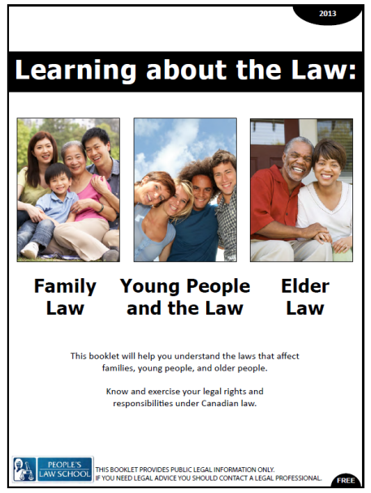

Listening Package: Young People and the Law
Lesson Objectives
    - Identify basic rights and responsibilities of young people in Canada
    - Describe law practices related to youth vs. adult law
    - Provide information about specific laws related to young people

Instructions for the Teacher

These listening tasks are based on the video on the Young People and the Law Lesson Module page at (insert link here)

The following listening tasks have been modelled on the CLB 7-10 Exit Assessment Tasks that CLB 7/8 students take to progress or exit their programs. You may choose to use the tasks in a variety of ways:

- As a practice test
  - do not allow dictionaries or other supports
  - give each student a copy of the listening task
  - read the instructions
  - play the video twice through without stopping, pausing for 30 seconds between viewing
  - gather the tests and score them
- As listening skills development
  - generate interest and activate prior knowledge
  - set a gist task (Who? Relationship? Mood?)
  - watch, confer with small groups
  - watch, stop, predict, confirm
  - give listening tasks (below)
  - watch, confer with small groups
  - discuss content of videos
  - role play a related workplace situation
- As self-study
  - assign as in-class, online or at home work

Video Script
(Actors: Police officer, man in 30’s with appropriate costume, youth aged 14-18, baggy clothes urban attire basically. The setting is during the day outside an abandoned lot with graffiti on wall.)
(Youth is spray painting wall while a police officer quietly walks up behind him and taps the youth on the shoulder, the youth turns around surprised and drops the paint can)
Officer: You do know that graffiti is illegal, don’t you?
Youth: It’s artwork.
Officer: On your own wall it maybe artwork but on someone else’s wall its called vandalism.
Youth: I don’t think my mom will allow me to spray paint our living room wall.
Officer: There is a legal spot to graffiti at Hastings Park.
Youth: I didn’t know that
Officer: Well you do now, so I better not see you back here. If I do you will be arrested for vandalism, and you will get a criminal record. Do you know what effect that will have on your future?
Youth: No
Officer: You won’t be able to travel to certain countries, and some jobs require a criminal background check and its tough enough out there to get work, do you want to make it even more difficult for yourself?
Youth: No, I don’t
Officer: Well then you better not be painting on this wall again some of the other officer’s won’t be as lenient as I am. Consider this your one and only warning young man.
Youth: Thank you, I want to be able to travel in the future I don’t want a record.
Officer: Alright there grab your stuff and head on down to Hastings Park.
Youth: Okay Sir (Youth grabs his back and paint and exits scene)

Listening Tasks
TASK A
You will watch a video of a young man speaking with a police officer. You will watch the video twice. As you watch, answer the questions. You have 30 seconds to read the questions before you listen.
Instructions: Circle the correct answer or fill in the blanks for each question or statement.
Score: /8

Questions
- Why did the police office approach the young man?
- The police officer wanted to arrest him for vandalism.
- The police officer wanted to inform him that graffiti is against the law.
- The police officer had to keep the young man away from the premises.

- Where does the police officer suggest he go?
- To his living room.
- To Hastings Street.
- To a different park where he is allowed to spray paint.

- What does the young man think about his painting?
- He thinks his painting is a piece of art.
- He thinks his painting looks better on the wall in his living room.
- He thinks that spray painting is just a cool thing to do.

- What is the police officer’s attitude toward the young man?
- He is very angry with him because he does not listen to him.
- He is easy on the young man and just gives him a warning.
- He feels sorry for him because he cannot travel to other countries anymore.
- Why does the police officer mention Hastings Park?
- To see if the young man knows that it is well known for artwork.
- To express that he understands what the young man is doing and to give him a better venue for it.
- To inform that it is a safe place for young people to be away from their parents.

- What would happen to the young man if he kept painting at the same place?
a) He would get a criminal record.
b) He would get a prize for his art.
c) He would be forced to paint the wall at Hastings Park.

- What did the officer say was one of the effects of a criminal record on the young man’s future?
- He would no longer be allowed to travel to any countries.
- It would stop him from ever getting a paid job.
- It would limit the jobs he might get hired for in the future.

- Where is the young man probably going?

________________________________________________________________________

TASK B
Instructions: Complete the chart by checking the person that the statements describe. There might be more than one check per statement. Score: /4

 | The young man | The police officer
knows that graffiti is illegal.
lives at home.
didn’t know that there is a designated graffiti park.
has a clean criminal record now.

Listening Tasks: Answer Key
TASK A
Instructions: Circle the correct answer or fill in the blanks for each question or statement.
Score:

Questions
- Why did the police office approach the young man?
- The police officer wanted to arrest him for vandalism.
- The police officer wanted to inform him that graffiti is against the law.
- The police officer had to keep the young man away from the premises.

- Where does the police officer suggest he go?
- To his living room.
- To Hastings Street.
- To a different park where he is allowed to spray paint.

- What does the young man think about his painting?
- He thinks his painting is a piece of art.
- He thinks his painting looks better on the wall in his living room.
- He thinks that spray painting is just a cool thing to do.

- What is the police officer’s attitude toward the young man?
- He is very angry with him because he does not listen to him.
- He is easy on the young man and just gives him a warning.
- He feels sorry for him because he cannot travel to other countries anymore.

- Why does the police officer mention Hastings Park?
- To see if the young man knows that it is well known for artwork.
- To express that he understands what the young man is doing and to give him a better venue for it.
- To inform that it is a safe place for young people to be away from their parents.

- What would happen to the young man if he kept painting at the same place?
a) He would get a criminal record.
b) He would get a prize for his art.
c) He would be forced to paint the wall at Hastings Park.

- What did the officer say was one of the effects of a criminal record on the young man’s future?
- He would no longer be allowed to travel to any countries.
- It would stop him from ever getting a paid job.
- It would limit the jobs he might get hired for in the future.

- Where is the young man probably going?

_______To Hastings Park__________________________________________________

TASK B
Instructions: Complete the chart by checking the person that the statements describe. There might be more than one check per statement. Score:

 | The young man | The police officer
knows that graffiti is illegal. |  | √
lives at home. | √
didn’t know that there is a designated graffiti park. | √
has a clean criminal record now. | √ | √

