Scams to Avoid

Listening Package

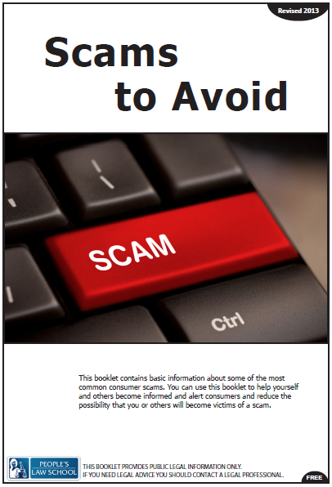

Listening Package: Scams to Avoid
Lesson Objectives
- Describe identity theft and scams and how to avoid them
- Give warnings and advice about how to recognize scams
- Identify what you can do to minimize the risk of identity theft or being scammed

Instructions for the Teacher

These listening tasks are based on the video on the Scams to Avoid Lesson Module page at (insert link here)

The following listening tasks have been modelled on the CLB 7-10 Exit Assessment Tasks that CLB 7/8 students take to progress or exit their programs. You may choose to use the tasks in a variety of ways:

- As a practice test
  - do not allow dictionaries or other supports
  - give each student a copy of the listening task
  - read the instructions
  - play the video twice through without stopping, pausing for 30 seconds between viewing
  - gather the tests and score them
- As listening skills development
  - generate interest and activate prior knowledge
  - set a gist task (Who? Relationship? Mood?)
  - watch, confer with small groups
  - watch, stop, predict, confirm
  - give listening tasks (below)
  - watch, confer with small groups
  - discuss content of videos
  - role play a related workplace situation
- As self-study
  - assign as in-class, online or at home work

Video Script
Steve: Hello
Caller: Hello, this Is Tom from Acme Collections, can I speak to Steve
Steve: Speaking
Caller: Yes, I’m calling in regards to a debt that you owe to G7 Loans in the amount of 7,000 dollars
Steve: What? There must be some mistake. I have no Idea what you’re talking about
Caller: This is Steve Carlyle correct?
Steve: Yes
Caller: Yes, no mistake then you took out a loan in the amount of 7,000 on Sept 3rd and after repeated attempts by the company to contact you, they have passed the debt onto us (Steve suddenly looks back to the pile of mail and starts opening them up, Letter after Letter is related to the fraud that has been committed against him) Mr. Carlyle? ……Mr. Carlyle?
Steve: I’ll have to call you back (Steve hangs up phone, stands there for a few seconds, Picks the phone back up and calls the Local Police)
Police Operator: Hello City Police how may I direct your call?
Steve: Fraud Department! (Scene ends with Steve still on the phone)

Listening Tasks
TASK A
Identity Theft
You will watch a video of a phone call between a man and someone calling to ask him about a loan. You will watch the video twice. As you watch, answer the questions. You have 30 seconds to read the questions before you listen.
Instructions: Circle the correct answer or fill in the blanks for each question or statement.
Score: /7

Questions
- What is Steve’s problem?
- He has been spending too much money.
- He forgot to pay off his debt.
- He got scammed.

- According to Tom, which month did Steve take out a loan?
__________________________________________________________________________

- Steve says that he will call back _______________________________
- Because he does not know who the caller is.
- Because he is too scared to talk to the caller.
- Because he realized what had happened to him.

- How much was the amount of the loan mentioned?
- 70,000 dollars
- 7,000 dollars
- 14,000 dollars

- Who does Steve call?
- The bank.
- G7 Loans.
- The police.

- Why did he make the phone call?
- To report that he might be the victim of a crime.
- To pay off his loan.
- To check the balance of his account.

- What is the relationship between Steve and Tom?
- Steve took out a loan from Tom’s company.
- Tom is calling on behalf of another company.
- Tom is trying to scam Steve.

Listening Tasks: Answer Key
TASK A
Instructions: Circle the correct answer or fill in the blanks for each question or statement.
Score: /7

Questions
- What is Steve’s problem?
- He has been spending too much money.
- He forgot to pay off his debt.
- He got scammed.

- According to Tom, which month did Steve take out a loan?
_____September____________________________________________________________

- Steve says that he will call back _______________________________
- Because he does not know who the caller is.
- Because he is too scared to talk to the caller.
- Because he realized what had happened to him.

- How much was the amount of the loan mentioned?
- 70,000 dollars
- 7,000 dollars
- 14,000 dollars

- Who does Steve call?
- The bank
- G7 Loans
- The police

- Why did he make the phone call?
- To report that he might be the victim of a crime
- To pay off his loan
- To check the balance of his account

- What is the relationship between Steve and Tom?
- Steve took out a loan from Tom’s company
- Tom is calling on behalf of another company
- Tom is trying to scam Steve

