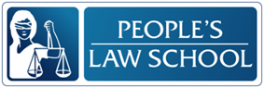

Driving in BC:
Getting a BC Driver’s License

CLB 5-6 Instructional Package

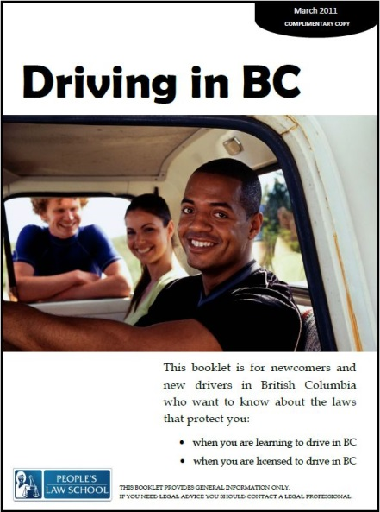

Lesson Plan: Getting a BC Driver’s License (CLB 5-6)
CLB Outcomes
CLB 6-II: Giving Instructions | Give sequential instructions and directions for everyday activities and processes.
CLB 5-II: Comprehending Instructions | Understand simple to moderately complex, step-by-step instructions and instructional texts for multistep procedures related to everyday situations.
CLB 5-II: Reproducing Information | Reduce a page of information to a list of important details.

Content Outcomes
- Identify the key steps in the process of getting a BC driver’s license
- Identify the rules associated with the graduated licensing system
- Identify where to get more information about getting a BC driver’s license

Resources
- People’s Law School (PLS) booklet, Driving in BC, p. 3-5
- PLS worksheets “Driving in BC: Getting a License”
- Computer Lab (optional)

External Resources and Referrals
- For more information on licensing, visit www.icbc.com.
- Invite a driving school instructor to speak to the class about common mistakes drivers make
- Visit an ICBC driver licensing centre near you; students can pick up a copy of ICBC’s Learn to Drive Smart booklet

Assessment Plan and Tools
- Self-assessment checklist

Lesson Plan: Getting a BC Driver’s License (CLB 5-6)
Time | Tasks | Expected Outcome | Resources
10’ | Warm up  - In pairs or small groups, students talk about pictures  - Go over vocabulary, if needed  - Assess level of knowledge of/ interest in driver licensing in BC | Generate interest  Activate prior knowledge | PLS Worksheet:  Get Ready!
15’ | Predict and read  - Copy and cut strips  - Students put the strips in order and then confirm their predictions by readingDriving in BC, p. 3-5  - Go over any new vocabulary, encourage students to apply word attack strategies i.e.:  - Ask for peer support  - Look at base form of word  - Guess the meaning from context  - Look in monolingual dictionaries | Identify the key steps in the process of getting a BC driver’s license  Identify where to get more information about getting a BC driver’s license | PLS Worksheet:  Predict!  Driving in BC, p. 3-5
15’ | Research and write notes  - In pairs, students can complete the list of steps, referring to the booklet as needed | Reduce a page of information to a list of important details. | PLS Worksheet:  Research and Write!  Driving in BC, p. 3-5
10’ | Discuss  - In small groups, students compare driver licensing cross-culturally | Think critically  Relate information to their own lives | PLS Worksheet:  Talk about it!
20’ | Read and compare  - Model finding the information in the booklet and selecting one rule to put in the chart  - In pairs, students complete the diagram  - Get pairs to present their answers with justifications | Understand simple to moderately complex, step-by-step instructions and instructional texts.  Identify the rules associated with the graduated licensing system | PLS Worksheet:  Read and Compare!  Driving in BC, p. 3-5
Lesson Plan: Getting a BC Driver’s License (CLB 5-6)

Time | Tasks | Expected Outcome | Resources
25’ | Role play giving instructions  - Teach and practice gambits for giving instructions  - Teach and practice pronunciation  - Identify register (level of informality)  - Students practice the dialogue in pairs until they are comfortable  - In new pairs, students practice the role play without a script | Give sequential instructions and directions for everyday activities and processes | PLS Worksheet:  Act it out!
20’ | Find out more  - Students find more information about getting a license by conducting internet research | Get more information about getting a BC driver’s license | Computer Lab  www.icbc.com
10’ | Self-Assessment  - Allow students to fill out self-assessment form independently | Self-assessment | PLS Worksheet:  What did I learn?

Lesson Plan: Getting a BC Driver’s License (CLB 5-6)
Get Ready!
Look at the picture below. What do you see? What is happening? What do you know about getting a driver’s license in BC?

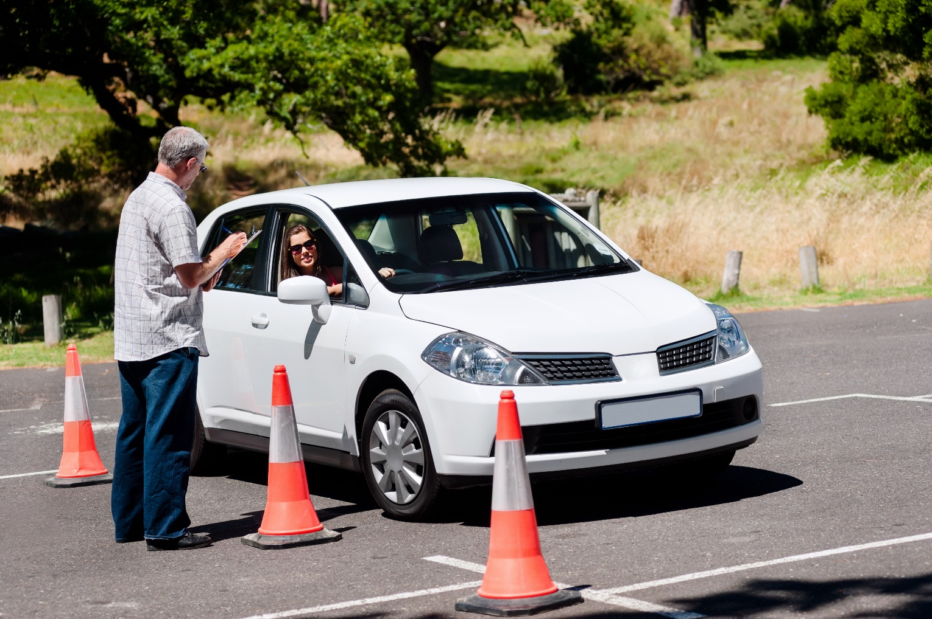

Image from Shutterstock.com

Lesson Plan: Getting a BC Driver’s License (CLB 5-6)
Predict!
Copy and cut these into strips. Get your students to put them in order before they look in the booklet. Note: These steps are for newcomers who had a license in their home country.

Find an ICBC Licensing Office near you. Their website is www.icbc.com.
Study the booklet, “Learn to Drive Smart.”
Take a practice knowledge test on the website www.icbc.com.
Go to an ICBC Licensing Office to take the Knowledge Test.
If you pass the Knowledge Test, make an appointment for the Road Test.
If you pass the Road Test, fill in some forms and pay a fee to apply for a driver’s license.
Congratulations! You now have a BC driver’s license.
Lesson Plan: Getting a BC Driver’s License (CLB 5-6)
Research and Write!
In pairs or small groups, complete the steps for people who have never had a driver’s license. Fill in the missing phrases.

- Find an________________ near you. Their website is www.icbc.com.
- __________________, “Learn to Drive Smart.”
- ________________knowledge test on the website www.icbc.com.
- Go to an ICBC Licensing Office to take the _____________.
- If you pass the Knowledge Test, make an appointment for ____________.
- If you pass the Road Test, fill in some forms and ____________ to apply for a driver’s license.
- If you have never had a driver’s license, you start with a _____________.
- After 12 months, you take a ___________.
- If you pass the test, you receive a ___________. After two years, you take a road test to receive a ___________.
- Congratulations! You now have a ______________________.

Talk about it!
How does this compare to getting a driver’s license in your country of origin?
Is it more or less difficult to get a driver’s license here? Why?
Have you tried to get a driver’s license in Canada? Do you want to? Why or why not?

Read and Compare!
In small groups, fill in this comparison diagram.
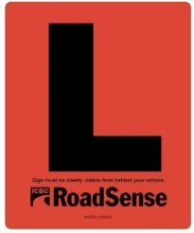
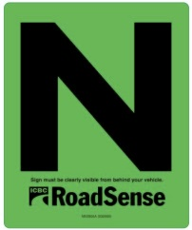
Rules for drivers with an L license
Rules for drivers with an N license
Rules for both

Lesson Plan: Getting a BC Driver’s License (CLB 5-6)
Act it out!
Practice asking for and giving instructions.

Giving Instructions
Asking how to do something
- Hey. You have your driver’s license, right? What do I need to do to get mine?
- Cindy, I need to get my driver’s license. Do you know how I can do that?
Describing how to do something
- Oh, yeah. It’s pretty easy. First, go to the ____, then take the ____. Finally, ____.
- Make sure you ______.
- Don’t forget to ______
Asking for clarification
- Woah. Slow down. I need to write this down.
- Ok, so before I can _____, I have to _____.
- What happens if _______.

Start like this:
A: Hi, Sarah. How’s it going? Did you get to the Farmer’s Market?
B: No, I didn’t. In the end, I just decided it was too far to bus.
A: Oh, what a shame.
B: Hey. You have your driver’s license, right? What do I need to do to get mine?
[Give instructions and ask for clarification]
Finish like this:
B: Ok, so before I book the road test, I have to pass the knowledge test.
A: That’s right.
B: Wow, I’m glad I asked you. You’ve saved me a lot of time.
A: Hey, no problem. I’m happy to help. I can help you study if you want.
B: Really? That’s awesome, thanks. I’ll take you up on that.
A: Please do. Anyway, I’ve got to run. Call me when you want to get together to study.
B: OK. Thanks again, Sarah. Have a good weekend.
A: You, too. See you.

Lesson Plan: Getting a BC Driver’s License (CLB 5-6)
Find out More!
Use a computer at school or at home to find out the following information. (Hint: remember the ICBC website is www.icbc.com )

- Where is the ICBC Driver’s Licensing Centre closest to your home? Write the full address.

- What is the BC Services card?

- Include one more piece of information that you think is important.

Lesson Plan: Getting a BC Driver’s License (CLB 5-6)
What did you learn?
Fill this out on your own.
 | Yes, I can do this on my own. | I need to review this. | I can’t do this yet.
I can list the key steps in the process of getting a BC driver’s license.
I can list some of the rules associated with the graduated licensing system (L and N licenses).
I can find information about getting a BC driver’s license.
I can ask for and give instructions.
I can understand written instructions.
I can write a list of important steps.

What else did you learn today? What other questions do you have about driving in BC?

Lesson Plan: Getting a BC Driver’s License (CLB 5-6)
Research and Write! ANSWER KEY
- Find an ICBC Licensing Office near you. Their website is www.icbc.com.
- Study the booklet, “Learn to Drive Smart.”
- Take a practice knowledge test on the website www.icbc.com.
- Go to an ICBC Licensing Office to take the Knowledge Test.
- If you pass the Knowledge Test, make an appointment for the Road Test.
- If you pass the Road Test, fill in some forms and pay a fee to apply for a driver’s license.
- If you have never had a driver’s license, you start with a learner’s license.
- After 12 months, you take a road test.
- If you pass the test, you receive a novice license. After two years, you take a road test to receive a full license.
- Congratulations! You now have a BC Driver’s License!

Lesson Plan: Getting a BC Driver’s License (CLB 5-6)
Find out More!
ANSWER KEY

- Where is the ICBC Driver’s Licensing Centre closest to your home? Write the full address.
Answers will vary
- What is the BC Services card?
Provides access to BC provincial government services for residents; serves as a heath card, license, and access to services that need photo ID.
- Include one more piece of information that you think is important.
Answers will vary.

