Learning about the Law Lesson: Working in BC

CLB 5-6 Instructional Package

Lesson Plan: Working in BC (CLB 5-6)
CLB Outcomes
CLB 6-IV: Sharing Information | Ask for and give information in some detail; expressing opinions, feelings, obligation, ability and certainty one-on-one and in small group discussions or meetings.
CLB 5-III:Getting Things Done | Get information from simple to moderately complex business or service texts (such as public announcements, brochures, notices, business letters and flyers).
CLB 6-III: Getting Things Done | Write a short business or service correspondence for routine purposes.

Content Outcomes
- Identify and understand the minimum standards for hours of work, overtime, averaging agreements, and meal breaks
- Identify and understand the rights of employees when losing a job and the responsibilities of employers when laying off employees
Resources
- People’s Law School (PLS) Learning about the Law Wikibook, or Learning about the Law (Working in BC, Renting a Home) booklet (hardcopy, published 2013).
- PLS worksheets “Learning about the Law: Working in BC”
- Computer Lab (optional)
External Resources and Referrals
- Factsheets on the Employment Standard Branch website: www.labour.gov.bc.ca/esb
- For reviewing business writing, consult LINC 5-7 Classroom Activities, Volume 1, Chapter 2 at http://www.moresettlement.org/LINC5-7Activities/LINC_5-7_Classroom_Activities_Volume1.pdf
Assessment Plan and Tools
- Self-assessment form

Sample Lesson Plan
Time | Sample Tasks | Expected Outcome | Resources
10’ | Warm up  - In pairs or small groups, students talk about the pictures | Activate prior knowledge | PLS Worksheet:  Get Ready!
15’ | Conversation dialogue  - Students practice the dialogue in pairs  - Have students work together to fill in the gaps with the correct connectors from the choices in the box  - Students role play or practice the conversation and create their own using various connectors | Prepare for the topic of the lesson  Practice conversation strategies of turn taking | PLS Worksheet:  Let’s Talk!
15’ | Vocabulary match  - Students match vocabulary terms with meanings  - Encourage students to guess from context, use monolingual dictionaries, or ask each other for help | Understand key vocabulary for reading comprehension | PLS Worksheet:  Check Your Vocabulary!  Refer to Working in BC Wikibook
20’ | Discuss and read  - Students work in small groups to discuss and share what students already know, read and take notes, and share information with group members | Activate and share prior knowledge  Read and take notes for sharing information | PLS Worksheet:  Group Research!  PLS Learning about the Law Wikibook or booklet
20’ | Share and compare  - Review or teach the use of the first conditional (If + simple present to talk about real possible situations)  - Students work in groups of 5 – 6 to do a speaking activity in order to discover more about each other’s countries and employment laws | Compare and share information | PLS Worksheet: What If!

Time | Sample Tasks | Expected Outcome | Resources
20’ | Read and compare  - Students compare their own countries’ laws with the employment laws in BC  - Students skim PLS booklet to fill in the chart  - Students listen to other group members to fill out the remainder of the chart | Skim the text for information and take notes  Listen to take notes | PLS Worksheet: Country Compare!  PLS Learning about the Law Wikibook or booklet
20’ | Discuss and role play  - Students discuss and brainstorm various work scenarios and then role play conversations between employee and employer  - Students share and discuss personal experiences | Listen and identify details, style, register and some feelings in a social conversation  Give detailed information about an incident and express opinions and feelings | PLS Worksheet:  Talk about It!
25’ | Write an email  - Review business writing  - Students write an email to the manager | Write an email in proper format and language to clearly convey the intended message | LINC 5-7,  Vol. 1, Ch. 2  PLS Worksheet:  Send an Email!
25’ | Find out more  - Students find out more about the Employment Standards Branch  - Dial-A-Law | Understand key points in video or audio clips | PLS Worksheet:  Find out More!
10’ | Self-Assessment  - Allow students to fill out self-assessment form independently | Self-assessment | PLS Worksheet: What did you learn?

Get Ready!
Look at the pictures below. What do you see? How are these pictures related to work?
- 2.
- 4.

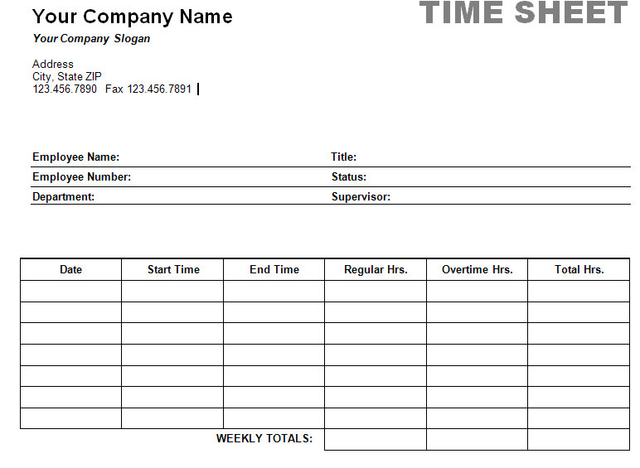

Let’s Talk!
Work in pairs to read the conversation between Ethan and Jonathon. Look at the conversation connectors and choose appropriate ones to fill in the gaps in the conversation.

Conversation Connectors
Taking Turns
- Hey
- Hi
- Well
- So
- Really
- Gees
Responding& Showing Interest
- Oh yeah
- Really
- Wow
- That’s interesting
- I can’t believe it
- I see
- Hmm

Ethan: _______, Jonathon, how’s the new job.
Jonathon: _______ Ethan. Not bad. I’m totally relieved to have found a job. I was getting really low on funds.
Ethan: Not bad? What? You’re not all excited?
Jonathon: _______, the work is interesting, but, it’s the meal breaks. The boss doesn’t give us a lunch break until after five hours. He doesn’t even give us a coffee break! Can he do that?
Ethan: _______, unfortunately, my friend, he can. Go check out the Employment Standards website.
Jonathon: _______. What am I going to do? You know I have diabetes and have to watch my blood sugar. What if my sugar goes really low? I can’t eat on the job!
Ethan: Talk to your boss. I’m sure that if he knows your situation and sees you munching away on the job, he will understand that it’s for medical reasons and that you’re not slacking off.
Jonathon: _______, maybe you’re right. I’d rather be safe than sorry. I’ll speak with him tomorrow.

Check Your Vocabulary!
Match the words to the definitions below. Write the words next to the definition.

agreement establish entitlement notice complicated
overtime required layoff available temporary
average minimum compensation provide schedule
- ___________________________ payment for services or loss of something
- ___________________________ a list of things to do; a time table
- ___________________________ have same opinion, understanding
- ___________________________ information, announcement or warning in written form
- ___________________________ necessary
- ___________________________ hours worked after regular time
- ___________________________ ready to be used; free to do something
- ___________________________ lowest possible
- ___________________________ set up
- ___________________________ difficult to explain
- ___________________________ no work for the employees
- ___________________________ have the right to; to be owed
- ___________________________ give
- ___________________________ for only a short time
- ___________________________ a level typical of group or series (ex. 1,1,3,3; = 2)

Group Research!
Follow the steps below to work through the chart.
- Discuss: Work in a group of 4 to discuss what you know about the topics listed below. Each member chooses one topic and keeps notes on this topic in the What We Know column below.
- Read: Read the information in the Working in BC section of the PLS Learning about the Law Wikibook or booklet, for your topic. Check and correct, if necessary, any information in the What We Know column. Add any new information in the What We learned column.
- Share: Share what you have learned about your topic with the group. Complete the What We Learned column by taking notes from other group members’ research.

Topic | What We Know | What We Learned
Minimum Wage &
Hours of Work

Averaging Agreements

Overtime

Meal Breaks & Losing
Your Job

What If?
Cut up the cards and hand out a set to each group of 5 – 6 students. Students place the cards face down and take turns picking one card and forming first conditional questions to find out about each other’s countries.
Example: “What if you work overtime in your country? Do you get paid extra? Do you get time off?” Etc.
…you work overtime. | …you get sick and can’t go to work. | …you work during national holidays. | …you want to take a vacation.
…your company does not have enough work for you. | …your boss doesn’t treat you fairly. | …you break or damage something at your workplace. | …you work more than 40 hours a week.
…your employer doesn’t pay you what they agreed to pay you. | …you want to find out about the employment standards laws. | …you don’t take any holidays from your work during the year. | …you get laid off from your job.
…you work 8 hours a day. | …you want to find a job. | …you want to quit your job. | …you get injured at your workplace.
Read and Compare!
Skim the section on Working in BC in the PLS Learning about the Law Wikibook or booklet to find out how laws in BC compare to your country. Write notes about the laws in BC and then check off how these laws compare to your country – same, different, you are unsure.
Topic | BC, Canada | Same | Different | Unsure
pay for overtime
minimum wage
meal breaks
pay for vacation
hours of work
getting laid off | -layoffs are temporary  - can receive compensation  - employer doesn’t have to tell you ahead of time  -can receive compensation if it becomes permanent
employment laws
statutory
holidays

Talk about It!
Work in small groups. Choose a group leader and choose a secretary. The group leader makes sure that everyone has a chance to speak for each question. The secretary records the list for question 3.
Discuss:
- Have you ever had to speak to your boss about a personal matter? How did your boss respond?
- Did you, or somebody you know, have troubles at work because of a medical condition or personal matter? What happened?
- What kind of requests do employees ask of their employers?
Act it out:
- As a whole class, make a class list of the situations discussed in question 3 above.
- In your groups, take turns role playing the different situations.
Helpful Language
To get you started  Hello,____  Excuse me, ______  Do you have moment?  Are you busy?  Can speak to you about____?  Can I ask you something?  I’d like to speak to you about _________  I’d like to ask you about _______  I’d like to ask you if _______  I’m wondering ________  I’d like to talk to you about _____  I want to talk to you about _____ | Responding  Sure. Go ahead.  Sure, what would you like to talk about?  Sure, what would you like to ask?  Continuing the conversation  I see. So what you mean is ______  So what you are asking is _______  Hmm. Could you repeat that, please?  I understand. However,…
Send an Email!
Compose an email to your manager explaining your situation and requesting overtime pay.
Your Situation: In July 2013 you had worked 2 hours overtime on the 17th and 3 hours overtime on the 24th. You received your final paycheque and paystub for July and noticed that you were paid your regular 40 hours and there was no amount in the “time bank”.
- You receive minimum wage. Calculate the overtime pay that is owed to you.
- Write an email to your manager explaining the situation and requesting your overtime pay.

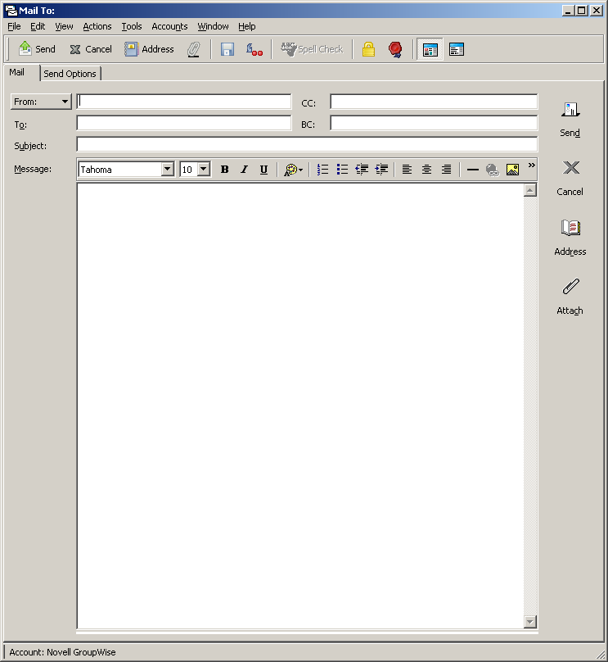

Find out More!
Discover more about the laws in BC by vising www.labour.gov.bc.ca/esb. Choose 3 or 4 topics that you want to learn more about and take notes on the information you find from the website.
Topics I want to learn more about: | What I discovered:
What did you learn?
Fill this out on your own.
 | Yes, I can do this on my own. | I need to review this. | I can’t do this yet.
I can understand the gist of a conversation.
I can understand and participate in a discussion and make myself understood.
I can compose an email to a manager.
I can compare my own country’s laws with BC laws for employment.
I can provide information so that others can take notes.
I can take notes by listening to others provide information.

Complete the following chart:
Important information I learned in this lesson: | What I would like to learn more about: | Where I will look for this information:
Let’s Talk!
ANSWER KEY
Ethan: Hey, Jonathon, how’s the new job.
Jonathon: Hi Ethan. Not bad. I’m totally relieved to have found a job. I was getting really low on funds.
Ethan: Not bad? What? You’re not all excited?
Jonathon: Well, the work is interesting, but, it’s the meal breaks. The boss doesn’t give us a lunch break until after five hours. He doesn’t even give us a coffee break! Can he do that?
Ethan: Hmm, unfortunately, my friend, he can. Go check out the Employment Standards website.
Jonathon: Gees. What am I going to do? You know I have diabetes and have to watch my blood sugar. What if my sugar goes really low? I can’t eat on the job!
Ethan: Talk to your boss. I’m sure that if he knows your situation and sees you munching away on the job, he will understand that it’s for medical reasons and that you’re not slacking off.
Jonathon: Well, maybe you’re right. I’d rather be safe than sorry. I’ll speak with him tomorrow.

Check Your Vocabulary!
ANSWER KEY
- compensation payment for services or loss of something
- schedule a list of things to do; a time table
- agreement have same opinion, understanding
- notice information, announcement or warning in written form
- required necessary
- overtime hours worked after regular time
- available ready to be used; free to do something
- minimum lowest possible
- establish set up
- complicated difficult to explain
- layoff no work for the employees
- entitlement have the right to; to be owed
- provide give
- temporary for only a short time
- average a level typical of group or series (ex. 1,1,3,3; = 2)

Read and Compare!
ANSWER KEY
Topic | BC, Canada | Same | Different | Unsure
pay for overtime | - employer must pay overtime if you work after 8 hours in a day or more than the regular 40 hours in a week  - can bank overtime and take time off instead of getting paid  - for each hour you work after 12 hours, employer must pay double-time
minimum wage | - $10.25 in BC  - set by province  - lowest amount your employer can pay  - is a law  - same for full-time and part-time workers
meal breaks | - can work for 5 hours with no break  - employer must give a break of at least 30 minutes after 5 hours of work  - not required to provide coffee breaks
pay for vacation | - After 12 months, 2 weeks of paid vacation  - five or more years with same employer, 3 weeks  - must take vacation within 12 months of earning it  - if you leave job before using vacation, employer must pay for those days  - statutory holidays are over and above vacation days
hours of work | - full time = 40 hours a week, 8 hours a day  - averaging agreements can be made to change the arrangement of hours and scheduling
getting laid off | - layoffs are temporary  - can receive compensation  - employer doesn’t have to tell you ahead of time  - can receive compensation if it becomes permanent
employment laws | - minimum work standards for working conditions  - protects worker and basic rights as a worker  - a law  - not everyone is protected under this law  - farmers (only some)  - not veterinarians, lawyers, babysitters and students
statutory holidays | - 10 statutory holidays in BC  - don’t work on these days  - get paid if you’ve worked more than 30 calendar days and 15 of the 30 days before holiday

Photo credit: Shutterstock.com

